




Decoding Supply Chain Chaos: A Data-Driven Power BIAnalysis

Project Domain
Excel, Power BI, Copilot Studio & Power Apps

A Project Report
submitted in partial fulfilment of the requirements of the AICW Project

by:



Student Name
Ishita Singhal

Student Email
singhalishita1011@gmail.com
Guide
Uma Maheshwari

Institution:
Graphic Era Deemed To be University

Year - 2026
ACKNOWLEDGEMENT

We would like to take this opportunity to express our deep sense of gratitude to all individuals who helped us directly or indirectly during this project work.

Firstly, we extend our sincere thanks to our supervisor for being an excellent mentor and adviser. Their guidance, encouragement, and constructive feedback served as a source of innovative ideas and inspiration, and were central to the successful completion of this project.

We extend our sincere thanks to the Edunet Foundation, Microsoft, LinkedIn, and SAP for providing this fellowship opportunity, the learning resources, and the platform to develop and showcase our AI and data analytics skills through real-world business problems.

We are also grateful to our institution for providing the necessary infrastructure and support throughout the project duration. The access to Power BI Desktop and relevant datasets enabled us to build a comprehensive, multi-page analytical dashboard covering the Pacific Asia supply chain domain.

Finally, we thank our family and friends for their continuous encouragement and support throughout this journey.

ABSTRACT OF THE PROJECT

ABSTRACT OF THE PROJECT
This project is part of the AICW (Artificial Intelligence in the Contemporary World) Fellowship Program, a collaborative initiative by Edunet Foundation in partnership with Microsoft, LinkedIn, and SAP, designed to equip students with practical, hands-on skills in Artificial Intelligence, Data Analytics, and Business Intelligence tools.

This project focuses on the analysis and visualization of supply chain and e-commerce order data for the Pacific Asia region, using Microsoft Power BI. The dataset comprises 2,263 cleaned order records across 48 fields, covering four key sub-regions: Southeast Asia, Oceania, Eastern Asia, and South Asia. The data was sourced from a publicly available supply chain dataset and underwent thorough cleaning including date standardization, discount recalculation, missing value treatment, and data type correction.

The Power BI dashboard built for this project consists of nine interactive pages: Executive Summary, Regional Intelligence, Product & Category Analysis, Shipping & Delivery, Customer Analytics, Risk & Compliance, Root Cause Analysis, Order Detail Drill-Through, and Business Insights. Key findings include a total revenue of $390,818.68 with a net profit of $39,501.77, an alarming late delivery rate of approximately 56.6% across all regions, and a dominance of Standard Class shipping. The Consumer segment emerges as the highest revenue contributor, while Consumer Electronics and DVDs lead in profit margin. Southeast Asia and Oceania are the top-performing regions by both revenue and profit.

The dashboard provides actionable business intelligence for supply chain managers, logistics teams, and executive decision-makers to identify bottlenecks, optimize shipping strategies, mitigate risk, and improve customer satisfaction across Pacific Asia markets. To operationalise these insights, the project also delivers a Microsoft Power Apps AI Builder prediction model (trained on the dataset with an 87% r-squared score) that predicts late delivery risk per order, integrated into an automated Power Automate flow (Late Delivery Alert) that runs daily, checks every active order using the AI model, and sends an email alert when the model predicts late delivery with above 70% confidence. A second flow (Monthly Discount Review) provides scheduled email reporting. Additionally, the TradeRoute — Supply Chain Intelligence AI agent, built in Microsoft Copilot Studio, which answers plain-English business questions against the full dataset and analytics report. Finally, the project is deployed as a live, publicly accessible Streamlit web application hosted on Microsoft Azure (Canada Central region) at https://ishitafp-frh6bmavghc7aeb0.canadacentral-01.azurewebsites.net/, packaged as a Power BI Risk Console that unifies the embedded Power BI dashboard, barcode-based order lookup, and a built-in Order Risk & Anomaly Detector into a single guided operator interface.

TABLE OF CONTENTS

Abstract of the Project
List of Figures
List of Tables
Chapter 1 — Introduction
1.1 Problem Statement
1.2 Motivation
1.3 Objectives
1.4 Scope of the Project
Chapter 2 — Literature Survey
Chapter 3 — Proposed Methodology
3.1 System Design
3.2 Modules / Components Used
3.3 Data Flow Diagram (DFD)
3.4 Advantages
3.5 Requirement Specification
Chapter 4 — Implementation and Results
4.1 Data Cleaning Results
4.2 Dashboard Visualization Results
4.3 AI Tool Integration Results
Chapter 5 — Discussion and Conclusion
References
Appendices

LIST OF FIGURES
Figure No. | Figure Title / Description | Page No.
Figure 1 | Raw / uncleaned dataset screenshot (before cleaning) | —
Figure 2 | Cleaned dataset and Cleaning Report summary | —
Figure 3 | Executive Summary Dashboard — Revenue, Profit, Order Status | —
Figure 4 | Regional Intelligence Page — GDP Scatter, Late Delivery Funnel | —
Figure 5 | Product & Category Page — Treemap and Combo Chart | —
Figure 6 | Shipping & Delivery Page — Gauge and Stacked Column Chart | —
Figure 7 | Customer Analytics Page — Segment Donut and City Bar Chart | —
Figure 8 | Risk & Compliance Page — Waterfall, Fraud & Cancellation KPIs | —
Figure 9 | Business Insights Page — Key Drivers and Smart Narrative Cards | —
Figure 10 | DFD Level 0 — Context Diagram | —
Figure 11 | DFD Level 1 — Detailed Process Flow | —
Figure 12 | TradeRoute AI Agent — Copilot Studio Overview and Sample Response | —
Figure 13 | TradeRoute AI Agent — Tool Configuration and MCP Connectors | —

LIST OF TABLES
Table No. | Table Title / Description | Page No.
Table 1 | Raw dataset summary — field names, data types, row count | —
Table 2 | Data cleaning report — issues found and fixed | —
Table 3 | Hardware Requirements | —
Table 4 | Software Requirements | —
Table 5 | Key findings and results summary | —
Table 6 | Regional performance metrics | —

CHAPTER 1 — Introduction
This chapter introduces the project undertaken as part of the AICW Fellowship Program. It outlines the background, the problem being addressed, the motivation behind the work, and the objectives and scope of the project. This project falls under the domain of Business Intelligence and Data Analytics, using Power BI to analyse supply chain order data for the Pacific Asia region.

1.1 Problem Statement
Supply chain operations in the Pacific Asia region are characterised by high transactional volumes, complex logistics networks, multi-regional delivery requirements, and diverse customer segments. Organizations managing e-commerce and supply chain operations in this geography frequently encounter operational inefficiencies that directly impact customer satisfaction, profitability, and compliance.

The following core business problems have been identified in this project:
- High Late Delivery Rate: Over 56.6% of orders (1,281 out of 2,263) are flagged as having late delivery risk. This is a critical operational failure that erodes customer trust and increases return and complaint rates.
- Shipping Mode Inefficiency: First Class and Second Class shipping modes exhibit late delivery rates of 97.5% and 78.7% respectively — indicating that premium shipping options are ironically the least reliable, suggesting systemic routing or process failures.
- Revenue and Profit Imbalance Across Regions: Despite similar revenue levels, Eastern Asia generates significantly less profit ($4,031) compared to Oceania ($13,260) — pointing to structural cost inefficiencies or excessive discounting in low-GDP markets.
- Discount-Driven Profit Erosion: Men's Clothing shows a negative average profit ratio (-17.9%), suggesting that excessive discounting in certain categories is actively destroying value.
- Fraud and Cancellation Risk: Orders flagged as SUSPECTED_FRAUD (45 orders) and CANCELED (48 orders) represent direct revenue and compliance risk that requires active monitoring and mitigation.
- Underutilised Regional Intelligence: Despite variation in GDP per capita ($6,000 in South Asia vs. $55,000 in Oceania), urbanization index, and logistics scores across regions, these variables are not being leveraged to tailor pricing, shipping, or product strategies.

1.2 Motivation
The Pacific Asia region is one of the fastest-growing e-commerce and supply chain markets in the world. With rising consumer demand, increasing internet penetration, and diversifying product categories, businesses operating in this space need robust analytical tools to remain competitive.

The motivation for this project stems from the recognition that while large volumes of transactional data are being collected, this data remains underutilised without proper analytical frameworks. Power BI provides an opportunity to transform raw operational data into actionable intelligence — enabling supply chain managers, executives, and logistics teams to make data-driven decisions.

Additionally, this project aligns with the AICW Fellowship's objective of developing practical AI and Business Intelligence skills that are directly applicable to real-world industry challenges. Building a nine-page interactive dashboard that addresses multiple dimensions of supply chain performance — revenue, delivery, customer behaviour, risk, and regional intelligence — provides tangible, professional-grade experience in data storytelling and BI tool development.

1.3 Objectives
- To collect, explore, and understand the structure, fields, and data quality of the Pacific Asia supply chain dataset (2,263 rows × 48 columns).
- To clean and preprocess the raw dataset by standardizing date formats, correcting discount calculation errors, handling missing values, and fixing data type inconsistencies.
- To perform domain-specific analysis using Power BI DAX measures to compute KPIs including Total Sales, Total Profit, Late Delivery %, Profit Ratio, and Loss Impact values.
- To build a nine-page interactive Power BI dashboard that communicates supply chain performance insights across executive, regional, product, shipping, customer, and risk dimensions.
- To identify actionable business insights — including top-performing regions, highest-risk shipping modes, most profitable product categories, and key drivers of late delivery risk.
- To document the complete project process and provide business recommendations based on dashboard findings for supply chain optimization in the Pacific Asia market.

1.4 Scope of the Project
- This project covers order and shipment data from the Pacific Asia market spanning the period December 2017 to December 2018, comprising 2,263 order records across four regions: Southeast Asia, Oceania, Eastern Asia, and South Asia.
- The primary tool used is Microsoft Power BI Desktop for data modelling, DAX measure creation, and dashboard visualization. Data cleaning was performed using Excel and Power Query.
- The analysis focuses on six key dimensions: executive KPIs, regional intelligence, product and category performance, shipping and delivery efficiency, customer analytics, and risk and compliance monitoring.
- The project does not include real-time data integration, predictive machine learning models, or API-based data pipelines. It is based on a static historical dataset.
- The dashboard is designed as a fellowship showcase and analytical prototype. It is not intended as a production-level deployed system.

CHAPTER 2 — Literature Survey

2.1 Existing Work and Research
Supply chain analytics has attracted significant academic and industry interest, particularly in the context of emerging Asia-Pacific markets. Prior research has explored data-driven approaches to logistics optimization, demand forecasting, and customer segmentation. Studies by Chopra & Meindl (2016) on supply chain management establish the foundational framework for understanding trade-offs between delivery speed, cost, and reliability — themes directly reflected in the late delivery and shipping mode analysis in this project.

Research on Business Intelligence dashboards in supply chain contexts (Elbashir et al., 2011) demonstrates that well-designed BI systems improve operational decision-making by up to 35% compared to spreadsheet-based approaches. This supports the choice of Power BI as the primary visualization tool for this project.

In the domain of regional economic analytics, the inclusion of GDP per capita, urbanization index, and logistics scores in the dataset aligns with the World Bank's frameworks for measuring market maturity and infrastructure readiness — variables that influence pricing strategy, product mix, and delivery expectations in different sub-regions.

Existing solutions in the BI space often focus on single-dimension analysis (e.g., sales performance only). This project addresses the gap by building a multi-dimensional dashboard that integrates regional intelligence, risk compliance, and customer behaviour — providing a holistic view of supply chain performance.

2.2 Tools and Technologies Review
- Microsoft Power BI Desktop: A leading business analytics platform that provides interactive visualizations, DAX-based data modelling, and a rich library of visual types including maps, scatter charts, treemaps, decomposition trees, and key driver visuals. It was selected for its industry-standard adoption, free desktop availability, and suitability for supply chain dashboards.
- Microsoft Excel / Power Query: Used for initial data cleaning steps including date standardization, discount recalculation, and data type correction. Power Query provides a no-code ETL (Extract, Transform, Load) interface that integrates natively with Power BI.
- Custom Power BI Visuals: This project uses enhanced custom visuals including Connected Scatter Plot, Enhanced Scatter Chart, Polar Scatter Plot, Maps by Squillion, and Heatmap visuals — extending the analytical depth beyond standard Power BI offerings.
- DAX (Data Analysis Expressions): The query language used within Power BI to create calculated measures such as Total Sales, Total Profit, Late Delivery %, Profit Ratio, Fraud Count, Loss Orders, and Customer Count — enabling dynamic, filter-aware KPI computation.
- Microsoft Power Apps AI Builder: A low-code machine learning platform within the Power Platform used to train a custom Prediction model on the Asia_Pacific_orders dataset. The model was configured to predict the Late_delivery_risk column (binary outcome) using six selected feature columns: Customer Segment, Days for Shipment (Scheduled), Days for Shipping (Real), Department Name, Order Item Discount Rate, and Shipping Mode. After training, the model achieved an r-squared of 87% with a Grade A performance rating. The top predictive features identified were Days for Shipping (Real) at 50% influence and Days for Shipment (Scheduled) at 46% influence. The model was published and integrated into the Late Delivery Alert Power Automate flow, where it runs an AI prediction step on each active order row, enabling proactive delivery risk detection before a delivery becomes late. - Microsoft Power Automate: A cloud-based workflow automation platform used to operationalise dashboard findings. Two flows were built on top of the analytics layer — a daily-scheduled Late Delivery Alert flow (integrated with the AI Builder prediction model) and a monthly Discount Review flow — both of which send branded email notifications through the Office 365 Outlook connector, extending the project from descriptive BI into closed-loop supply chain automation.
- Microsoft Copilot Studio: A low-code conversational AI platform used to build the TradeRoute — Supply Chain Intelligence agent. The agent is grounded on the Pacific Asia dataset and analytics report, uses Model Context Protocol (MCP) connectors to Microsoft 365 knowledge sources (Work IQ User and Work IQ Copilot), and allows non-technical stakeholders to query supply chain KPIs in plain English without opening the Power BI dashboard directly.
- Libre Barcode 39 Font (SIL Open Font License): An open-licensed Code 39 TrueType barcode font used in the Order Detail Drill-Through page to render the Order ID field as a scannable barcode, enabling warehouse and logistics staff to cross-reference on-screen dashboard records with physical order labels.
- Streamlit (Python open-source framework) and Microsoft Azure App Service: Streamlit was used to build the project’s operator-facing web application, the Power BI Risk Console, which embeds the published Power BI report, provides barcode detection and decode retry on uploaded or live-captured images, performs order lookup against the cleaned Pacific Asia dataset, and runs a built-in Order Risk & Anomaly Detector that scores each order as Normal, Unusual, or High Risk. The application is deployed on Microsoft Azure App Service (Canada Central region) and is publicly accessible at https://ishitafp-frh6bmavghc7aeb0.canadacentral-01.azurewebsites.net/, making the complete analytics solution available in a browser without requiring Power BI Desktop.

2.3 Gaps Identified
- Most public supply chain dashboards focus exclusively on revenue and delivery metrics, omitting integrated risk and compliance monitoring. This project addresses this gap with a dedicated Risk & Compliance page that tracks fraud, cancellations, and loss-generating orders simultaneously.
- Regional economic context (GDP, urbanization, logistics scores) is rarely integrated into BI supply chain dashboards, despite its relevance to pricing and service-level decisions. This project incorporates these variables as analytical dimensions in the Regional Intelligence page.
- The Root Cause Analysis page using a decomposition tree is an underutilised BI technique in supply chain analytics, providing drill-down capability to identify which combination of shipping mode, region, customer segment, and discount rate most strongly drives late delivery risk.

CHAPTER 3 — Proposed Methodology

3.1 System Design
The project follows a structured five-phase data analytics pipeline designed to transform raw supply chain transactional data into a comprehensive, interactive Power BI dashboard.

- Data Source / Input: A cleaned Excel dataset (Pacific_Asia_CLEAN.xlsx) containing 2,263 order records and 48 fields, covering orders from December 2017 to December 2018 across four Pacific Asia sub-regions. A supplementary Regional Intelligence sheet provides GDP, urbanization, and logistics metadata for 20 region-country combinations.
- Data Cleaning: Performed in Excel / Power Query — standardizing date formats (mixed M/D/YYYY and YYYY-MM-DD unified to YYYY-MM-DD HH:MM:SS), correcting 1,024 shipping date entries where month and day were swapped, recalculating 145 discount values where Discount ≠ Price × Rate, filling 2 missing customer last name values, and converting Customer Zip code to zero-padded 5-character strings.
- Analysis / Processing: DAX measures created in Power BI for Total Sales, Total Profit, Profit Ratio, Late Delivery %, Order Count, Customer Count, Fraud Count, Cancelled Orders, Loss Orders, and financial loss impact metrics (Late Delivery Loss, Discount Loss, Fraud Loss, Cancellation Loss).
- Visualization / Output: A nine-page interactive Power BI dashboard with dynamic slicers, cross-filtering, drill-through functionality, and smart narrative AI cards. Pages cover Executive Summary, Regional Intelligence, Product & Category, Shipping & Delivery, Customer Analytics, Risk & Compliance, Root Cause Analysis, Order Detail, and Business Insights.

3.2 Modules / Components Used
- Module 1 — Data Ingestion: Loading the cleaned Excel file into Power BI Desktop and establishing the data model relationship between the ‘Orders_CLEAN’ sheet and the ‘RegionalIntelligence’ lookup table via the Order Region key.
- Module 2 — Data Cleaning: All cleaning was pre-applied in Excel. Power Query within Power BI was used to validate data types, confirm no remaining null values, and apply final column formatting.
- Module 3 — DAX Measure Library: Creation of 20+ calculated measures including financial KPIs, delivery performance metrics, risk indicators, and customer analytics measures, all stored in a dedicated Measures table.
- Module 4 — Dashboard Pages: Nine report pages built with 80+ visual components including card visuals, column/bar charts, donut charts, scatter charts, tree maps, funnel charts, gauge visuals, waterfall charts, ribbon charts, map visuals, decomposition trees, key driver visuals, and pivot tables.
- Module 5 — Business Insights AI Page: An AI-powered page featuring Power BI's Key Influencers visual for identifying the primary drivers of late delivery risk, alongside Smart Narrative cards that auto-generate text summaries of financial loss, top-performing segments, and risk indicators.
- Module 6 — Late Delivery Alert Automation: A Microsoft Power Automate flow (“Late Delivery Alert”) built on top of the AI Builder prediction model and the Asia_Pacific_orders Dataverse table. The flow runs on a daily recurrence schedule and executes the following five-step pipeline: (1) Fetch Orders — a “List rows” action queries the Asia_Pacific_orders Dataverse table with a filter (cr572_orderstatus eq 6) to retrieve all currently active and pending orders; (2) Loop — an “Apply to each” action iterates over every retrieved order row; (3) AI Prediction — a “Predict” action calls the published AI Builder prediction model, feeding each order’s feature values (Customer Segment, Shipping Mode, Discount Rate, Department Name, and Days for Shipment) into the model to obtain a late delivery risk prediction and confidence score; (4) Condition — a conditional check evaluates whether the AI prediction result equals “Late delivery” AND the model confidence exceeds 70%; (5) Alert — if both conditions are satisfied, a “Send an email notification (V3)” action dispatches a formatted alert email through the Office 365 Outlook connector, branded as the TradeRoute AI Supply Chain Monitoring System. This operationalizes the 56.6% late-delivery finding into a proactive, AI-driven notification system that identifies at-risk orders before delivery failure occurs.
- Module 7 — Monthly Discount Review Automation: A recurring Microsoft Power Automate flow (“Monthly Discount Review”) that runs on a monthly schedule and automatically emails a discount performance review to the supply chain team, with an embedded link to the live Power BI dashboard file on SharePoint.
- Module 8 — TradeRoute AI Conversational Agent: A custom AI business intelligence agent built in Microsoft Copilot Studio, named “TradeRoute — Supply Chain Intelligence”, grounded on the full 2,263-record dataset and the complete supply chain analytics report. The agent answers plain-English business questions about late delivery rates, regional profit margins, shipping mode performance, product category insights, discount impact, customer behavior, and fraud risk, returning responses with actual dataset figures and actionable recommendations — removing the Power BI expertise barrier for executives, finance leads, and supply chain managers.
- Module 9 — Power BI Risk Console Web Application: A Streamlit-based Python web application deployed on Microsoft Azure App Service in the Canada Central region and publicly hosted at https://ishitafp-frh6bmavghc7aeb0.canadacentral-01.azurewebsites.net/. The application unifies four operational features into a single guided browser-based interface. (1) Dashboard Viewer — embeds the published Power BI report and switches report pages using custom Streamlit page buttons in place of the native Power BI tabs, keeping business users inside one controlled interface. (2) Barcode Detection and Decode Retry — detects barcode or QR regions in an uploaded image or live camera frame, previews the detected crop, and retries decoding with grayscale, thresholding, and scale-up preprocessing variants; the decoded value is normalized as UPPER(TRIM(value)) before lookup. (3) Excel/CSV Order Lookup — matches the decoded value against likely lookup columns (barcode, SKU, item code, product code, order ID) in the Pacific Asia dataset and returns the matching rows in tabular form along with the matched column name and row count. (4) Order Risk & Anomaly Detector — scores every row and the matched barcode record as Normal, Unusual, or High Risk using a combined anomaly score built from Z-score outlier detection (z = (x - μ) / σ), IQR bounds (Q1 − 1.5×IQR, Q3 + 1.5×IQR), categorical rarity scoring (1 − category frequency), and an amount consistency check (|recorded_total − (quantity × unit_price)|). The console then surfaces risk summary cards, a top anomalies table, a matched-barcode risk card, and a reason breakdown such as “high price”, “unusual quantity”, “rare category”, or “total mismatch”, enabling the operator to move from scanning a physical label to a risk-assessed decision in a single flow.

3.3 Data Flow Diagram (DFD)
DFD Level 0 — Context Diagram
Raw Supply Chain Order Data (CSV/Excel) → [Pacific Asia Supply Chain Analytics System] → Cleaned Dataset + Interactive Power BI Dashboard + Discount review report + AI Conversational Agent + Late Delivery alerts

DFD Level 1 — Detailed Process Flow
DFD Level 1 diagram here shows the following sub-processes;
- Sub-process 1: Data Loading and Schema Validation (Excel → Power Query → Power BI Data Model)
- Sub-process 2: Data Cleaning and Transformation (Date fix, Discount fix, Null fill, Type correction → Cleaned Orders_CLEAN sheet)
- Sub-process 3: DAX Measure Computation (Sales, Profit, Late %, Fraud, Loss → Measures Table)
- Sub-process 4: Visualization and Dashboard Build (9 Pages → Interactive Reports with Slicers and Cross-filters)
- Sub-process 5: AI Builder Prediction Model (Late delivery risk prediction per order) + Power Automate Daily Alert Flow (Fetch orders → AI Predict → Condition → Email alert) + Monthly Discount Review report + TradeRoute AI Conversational Agent

3.4 Advantages
- Holistic Supply Chain View: The nine-page dashboard covers the complete supply chain performance spectrum — from executive KPIs to granular order-level drill-through — providing a single source of truth for decision-makers.
- Interactive and Dynamic: Slicers for Region, Shipping Mode, Customer Segment, Order Status, and Date allow users to filter the entire dashboard dynamically, enabling self-service analytics without requiring technical expertise.
- Regional Intelligence Integration: By incorporating GDP per capita, urbanization index, and logistics scores alongside operational metrics, the dashboard enables context-aware analysis that most standard supply chain tools lack.
- AI-Assisted Insights: The Key Influencers visual and Smart Narrative cards use Power BI's built-in AI capabilities to automatically identify statistical drivers of late delivery risk and generate plain-language summaries of findings.
- Risk-Focused Design: The dedicated Risk & Compliance page and Root Cause Analysis page enable proactive risk management — a feature absent from most standard supply chain dashboards.
- Scalability: The methodology and DAX framework can be extended to include additional regions, product lines, or time periods without restructuring the dashboard.

3.5 Requirement Specification
Hardware Requirements
Component | Specification
Processor | Intel Core i5 or higher (i7 recommended for large Power BI models)
RAM | Minimum 8 GB (16 GB recommended)
Storage | Minimum 50 GB free disk space
Display | 1920 x 1080 resolution or higher (dual monitor recommended)
Internet | Required for Power BI Service publishing and custom visual downloads

Software Requirements
Software | Details
Operating System | Windows 10 / 11 (64-bit)
Microsoft Power BI Desktop | Latest version — free download from Microsoft
Microsoft Excel | Microsoft 365 / Excel 2019 or later (for data cleaning)
Power Query | Built into Excel and Power BI Desktop
Custom Visuals | Connected Scatter, Enhanced Scatter, Maps by Squillion, Heatmap (from AppSource)
Web Browser | Google Chrome / Microsoft Edge (latest version) for Power BI Service
Microsoft Power Apps AI Builder | Low-code AI model platform used to train and publish a Prediction model on the Asia_Pacific_orders Dataverse table. Model predicts Late_delivery_risk using 6 feature columns; achieved r-squared of 87% (Grade A). Integrated into the daily Power Automate alert flow via a Predict action.
Microsoft Power Automate | Cloud-based flow automation with Office 365 Outlook connector — used for (1) daily Late Delivery Alert flow integrating AI Builder prediction model with 5-step pipeline (fetch orders, loop, AI predict, condition, email alert), and (2) monthly Discount Review recurrence email flow
Microsoft Copilot Studio | Low-code conversational AI platform — used to build the TradeRoute Supply Chain Intelligence agent with Microsoft 365 MCP knowledge connectors
Libre Barcode 39 Font | Open-source Code 39 TrueType font (SIL OFL) — used for rendering Order ID barcodes in the Order Detail Drill-Through page
Streamlit and Microsoft Azure App Service | Python-based open-source web framework (Streamlit) used to build the Power BI Risk Console — unified dashboard viewer, barcode detection, order lookup, and anomaly detector. Deployed on Microsoft Azure App Service (Canada Central) at https://ishitafp-frh6bmavghc7aeb0.canadacentral-01.azurewebsites.net/

CHAPTER 4 — Implementation and Results

4.1 Data Cleaning Results
The raw dataset was sourced from a public supply chain e-commerce dataset, representing orders placed in the Pacific Asia market. Before analysis and visualization could begin, a comprehensive data cleaning process was performed to ensure accuracy and consistency.

Dataset Overview
Parameter | Details
Dataset Name | Pacific Asia Supply Chain Orders
Source | Kaggle / Edunet-provided supply chain dataset
Original Size | 2,263 rows × 48 columns (Orders sheet)
Supplementary Sheet | RegionalIntelligence — 20 rows × 4 columns
Date Range | December 2017 to December 2018
Market Covered | Pacific Asia (Southeast Asia, Oceania, Eastern Asia, South Asia)

Data Cleaning Issues Found and Fixed
Issue Type | Column Affected | Rows Fixed | Description
Date Standardization | order date (DateOrders) | 2,263 | Mixed formats M/D/YYYY and YYYY-MM-DD unified to YYYY-MM-DD HH:MM:SS
Date Correction | shipping date (DateOrders) | 1,024 | 1,024 YYYY-DD-MM entries had month/day swapped → corrected. Ship < Order anomalies reduced from 64 to 431 entries.
Missing Values | Customer Lname | 2 | 2 rows with blank last name filled with 'Unknown' (Customer IDs 18347, 20439)
Data Type Fix | Customer Zipcode | 2,263 | Integer converted to zero-padded 5-char string (preserves codes like 00725, 07001)
Calculation Error | Order Item Discount | 145 | 145 rows: Discount ≠ Price × Rate → recalculated to match formula
Precision Fix | All numeric columns | 14 | Currency columns → 2dp; ratios/rates → 4dp; coordinates → 6dp
Whitespace | All text columns | 0 | Stripped leading/trailing spaces — none found

Cleaning Summary
Metric | Value
Total Rows | 2,263
Total Columns | 48
Missing Values Remaining | 0
Duplicate Rows | 0
Total Issues Fixed | 7 categories of issues resolved

Figure 1: Screenshot of raw/uncleaned dataset

Figure 2: Screenshot of cleaned dataset or data cleaning report summary
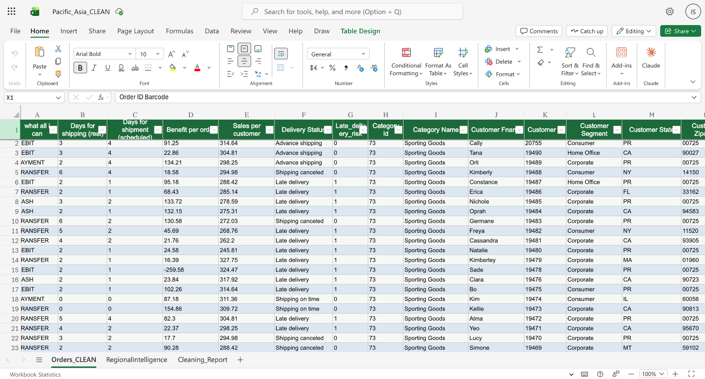

4.2 Visualization / Output Results
The Power BI dashboard comprises nine interactive pages. Each page addresses a specific analytical dimension of the Pacific Asia supply chain. Below is a detailed description and interpretation of each page, along with the key insights derived.

Page 1: Executive Summary
This is the primary landing page of the dashboard, providing a high-level overview of overall business performance. Key visuals include:
- Monthly Revenue vs. Profit Clustered Column Chart: Reveals the seasonal and monthly distribution of sales and profit over the 2017-2018 period, enabling identification of peak trading months and profit compression periods.
- Order Status Distribution Donut Chart: Shows that 757 orders (33.5%) are COMPLETE, while 492 (21.7%) are PENDING_PAYMENT — indicating a significant revenue collection risk from unconverted orders.
- Total Sales by Customer Segment and Shipping Mode Bar Chart: The Consumer segment dominates revenue across all shipping modes, followed by Corporate and Home Office segments.
- Revenue by Department Column Chart: Disc Shop leads department revenue, followed by Apparel and Fan Shop.
- KPI Cards: Display Total Sales ($390,818.68), Total Profit ($39,501.77), Total Orders (2,263), and Average Order Value ($172.70).
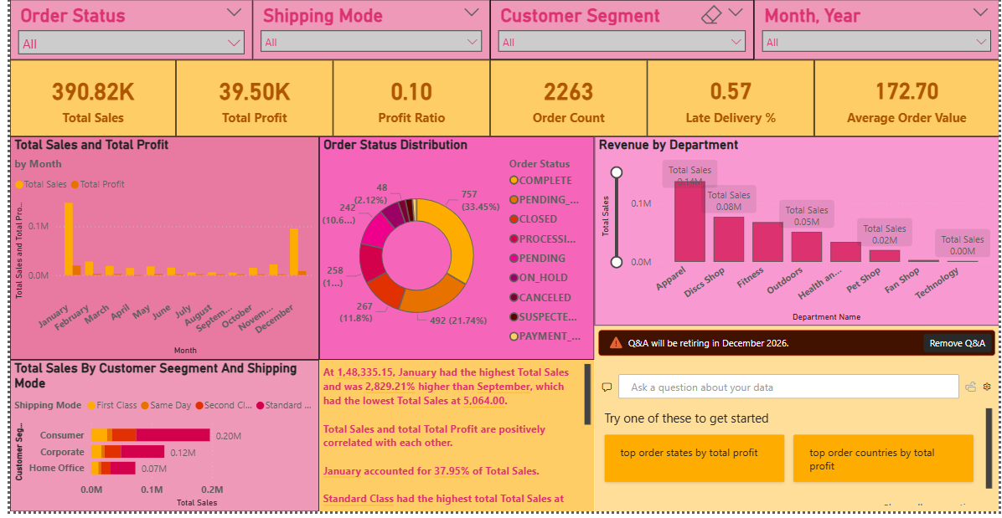
Page 2: Regional Intelligence
This page integrates regional economic context with supply chain performance metrics:
- GDP vs. Profit Ratio Scatter Chart: Plots each region's GDP per capita against its profit ratio and order volume (bubble size). Oceania, with the highest GDP ($55,000) and a logistics score of 3.8, achieves the best profit outcomes. South Asia (GDP $6,000, logistics score 2.5) underperforms proportionally, suggesting that infrastructure constraints are limiting profitability.
- Late Delivery % Funnel Chart by Region: All four regions exhibit dangerously high late delivery rates — Eastern Asia leads at 57.6%, followed by Southeast Asia (57.5%), Oceania (56.2%), and South Asia (54.9%). No region is performing acceptably on this metric.
- Revenue by Region and Delivery Status Ribbon Chart: Southeast Asia ($108,921) and Oceania ($108,624) are near-equal top revenue regions, with South Asia ($90,522) and Eastern Asia ($82,750) trailing.
- Total Sales by Geography Map: A geographic heat map showing concentration of order activity across Australia, Indonesia, India, the Philippines, and other Pacific Asia markets.
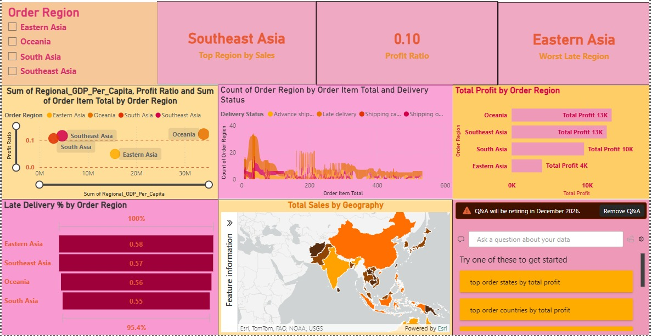

Page 3: Product & Category Analysis
This page examines sales and profitability by product and category:
- Sales by Category Treemap: Video Games is the largest category by sales volume (583 orders, $23,174 total sales). Women's Clothing (358 orders) and Toys (270 orders) follow. However, Consumer Electronics has the highest average profit ratio (24.3%) despite only 6 orders.
- Product Sales vs. Profit Ratio Combo Chart: Summer Dresses leads total sales at $77,263.56, followed by Smart Watch ($67,516.50) and Porcelain Crafts ($53,993.16). However, Men's Gala Suit shows the lowest profit performance.
- Discount Rate vs. Profit Ratio Scatter Chart: Reveals a negative correlation between discount rate and profit ratio — confirming that higher discounts are systematically eroding profit margins, particularly in Men's Clothing (-17.9% average profit ratio).
- Profit by Department Column Chart: Fitness and Disc Shop departments generate the highest profits, while Tech and Outdoors departments contribute least.
- Customer Segment vs. Category Sales Pivot: Consumer segment dominates sales across Video Games, Clothing, and Pet Supplies; Corporate segment leads in Sporting Goods.
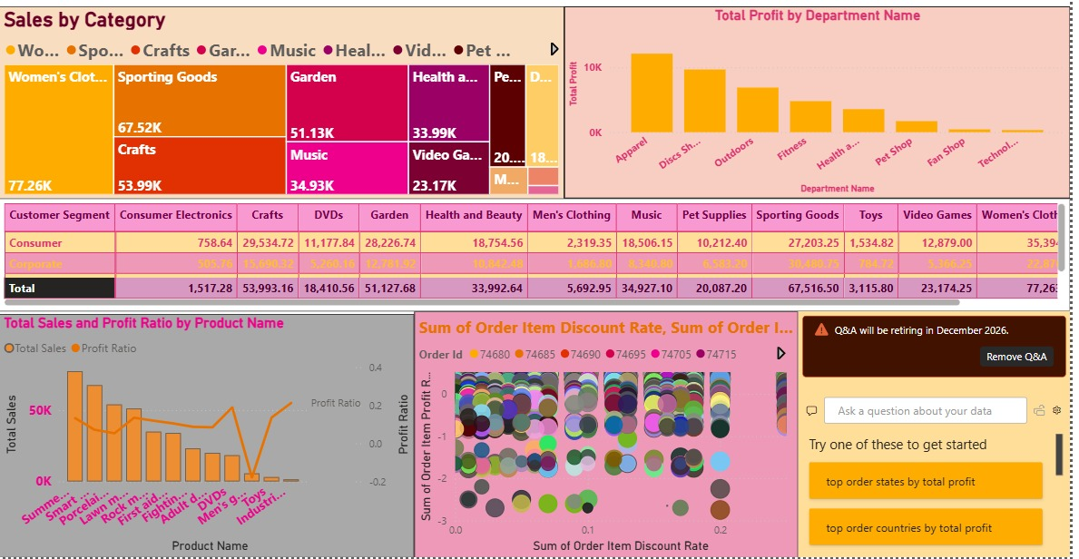

Page 4: Shipping & Delivery
This page analyses delivery performance and shipping mode efficiency:
- Late Delivery Gauge: Shows the overall late delivery rate at 56.6% — significantly above any acceptable threshold, indicating systemic delivery failure across the supply chain.
- Planned vs. Actual Shipping Time by Mode Chart: Standard Class (avg. ~4 days scheduled vs. ~3 days actual) and Same Day shipping perform within planned parameters. However, First Class and Second Class modes consistently overshoot their scheduled delivery windows, explaining their 97.5% and 78.7% late delivery rates respectively.
- Delivery Status by Shipping Mode 100% Stacked Column: First Class shipping has an almost entirely 'Late Delivery' composition — a counterintuitive finding that suggests routing or carrier assignment failures for this tier.
- Late Delivery % by Region Map: Geographically visualizes where delivery failures are most concentrated, supporting regional logistics investment decisions.
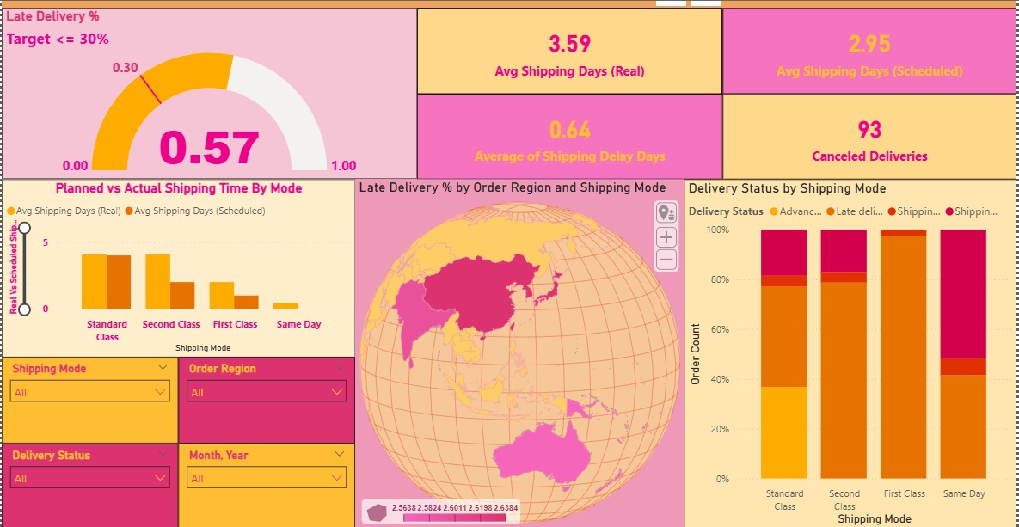

Page 5: Customer Analytics
This page profiles customer behaviour and geographic distribution:
- Customer Segment Distribution Donut: Consumer (51.2%), Corporate (28.7%), Home Office (20.1%). Consumer segment is the largest revenue driver.
- Top Cities by Revenue Bar Chart: Sydney leads with 93 orders, followed by Yakarta (76), Manila (75), Melbourne (57), Brisbane (54), and Bangkok (54) — identifying key geographic markets for targeted marketing investment.
- Payment Type vs. Order Count and Sales Line Chart: Comparison of DEBIT vs. PAYMENT transaction types shows relatively balanced distribution, with DEBIT transactions being slightly more frequent.
- Customer Segment vs. Category Ribbon Chart: Reveals the category preferences of each customer segment — enabling targeted product assortment and promotional strategies.
- KPI Cards: Total Customers (992 unique customers), Average Sales per Customer ($304.81).
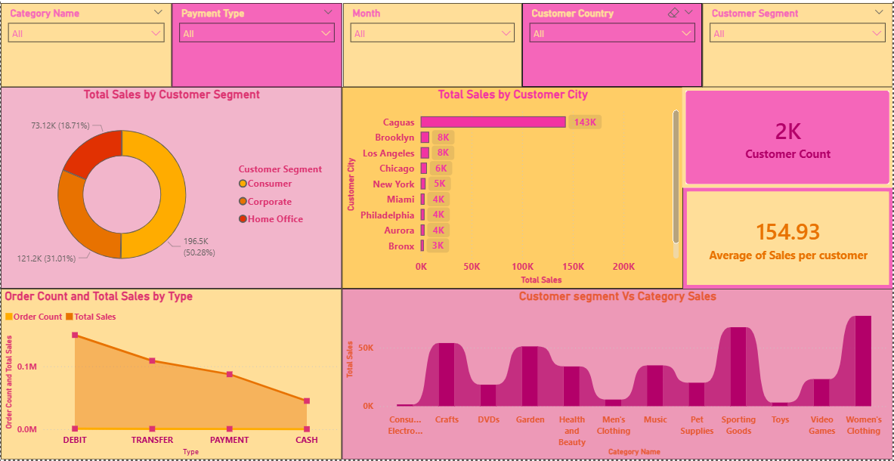

Page 6: Risk & Compliance
This page monitors risk factors and their financial impact:
- KPI Cards: Late Deliveries (1,281 orders), Cancelled Orders (48), Suspected Fraud (45 orders), Loss Orders (count of negative-profit orders).
- Fraud Count and Cancelled Orders by Region Bar Chart: Identifies which regions have the highest concentration of high-risk orders, enabling targeted compliance monitoring.
- Discount Rate vs. Profit Scatter Chart: Plots individual orders showing that high discount rates (above 15%) systematically produce negative or near-zero profit, quantifying the financial risk of uncontrolled discounting.
- Profit Reduction Due to Risk Factors Waterfall Chart: Quantifies the financial impact of each risk factor — late delivery, discount erosion, fraud, and cancellations — providing a clear picture of total value destruction across the supply chain.
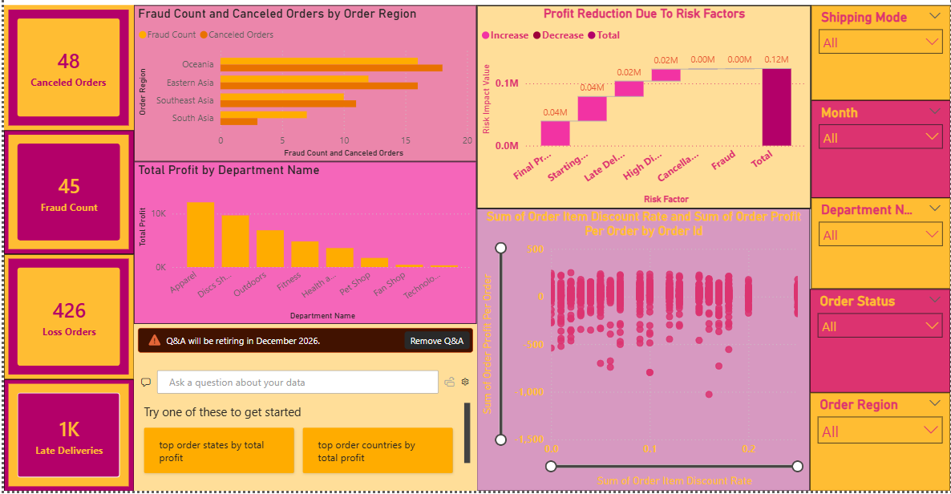

Page 7: Business Insights
The Business Insights page is the AI-assisted summary page of the dashboard, featuring:
- Key Influencers Visual: Power BI's AI-driven key drivers analysis identifies that First Class shipping mode is the single strongest driver of late delivery risk (increasing it by approximately 40 percentage points compared to baseline). Second Class shipping is the second highest driver. Orders in Eastern Asia with high discount rates also significantly increase late delivery risk.
- Smart Narrative Cards: Auto-generated text summaries of top revenue segment (Consumer), highest risk shipping mode (First Class), most profitable category (Consumer Electronics), and top region by sales (Southeast Asia).
- Financial Loss Impact Cards: Cancellation Loss, Discount Loss, Fraud Loss, and Late Delivery Loss — quantifying the total value destruction from each risk category and supporting prioritization of corrective actions.
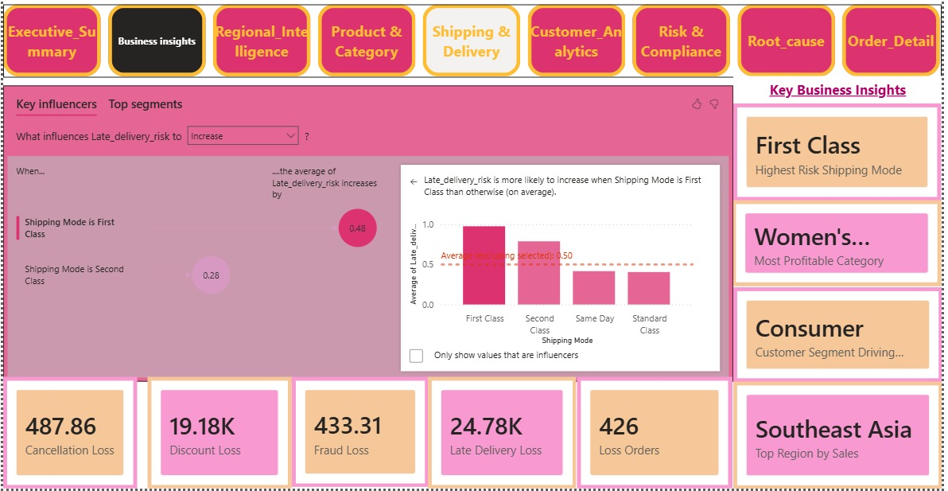

4.3 AI Tool Integration Results
Power BI's built-in AI features were utilized throughout the dashboard to enhance analytical depth and automate insight generation:
- Key Influencers Visual (Page 7): Automatically identifies the statistical drivers of late delivery risk by analysing relationships between late delivery rate and variables including Shipping Mode, Order Region, Customer Segment, and Discount Rate. This feature eliminates the need for manual correlation analysis.
- Smart Narrative / Q&A Visual (Pages 6 and 7): Auto-generates plain-language summaries of data findings, making the dashboard accessible to non-technical executives who may not interpret charts directly.
- Power Automate & AI Builder Integration: A full AI-powered late delivery alert system was built using Microsoft Power Apps AI Builder and Power Automate. The AI Builder Prediction model was trained on the Asia_Pacific_orders Dataverse table, configured to predict the Late_delivery_risk outcome using six feature columns: Customer Segment, Days for Shipment (Scheduled), Days for Shipping (Real), Department Name, Order Item Discount Rate, and Shipping Mode. The trained model achieved an r-squared of 87% (Grade A performance), with Days for Shipping (Real) identified as the most influential predictor at 50% feature importance, followed by Days for Shipment (Scheduled) at 46%. The model was published and connected to a scheduled Power Automate flow. The “Late Delivery Alert” flow runs daily and executes a five-step pipeline: it fetches all active orders from the Dataverse table (filtered by order status), loops through each order, calls the AI Builder Predict action to generate a late delivery prediction and confidence score, checks whether the prediction is “Late delivery” with confidence above 70%, and sends a branded TradeRoute AI email alert if both conditions are met. This converts the static 56.6% late-delivery insight from the Power BI dashboard into a proactive, AI-driven monitoring system that flags individual at-risk orders in real time. The “Monthly Discount Review” flow continues to run on a recurring monthly schedule, emailing the supply chain team a discount performance review with a direct SharePoint link to the live Power BI dashboard — closing the loop between BI insight and operational action.
- TradeRoute — Supply Chain Intelligence AI Agent (Microsoft Copilot Studio): A custom conversational AI agent was built in Microsoft Copilot Studio, grounded on the full 2,263-order Pacific Asia dataset and the complete supply chain analytics report. The agent responds to plain-English queries — for example “total profit by region” or “what are the total sales by region” — with structured, data-backed answers that reference actual dataset figures (for example, Oceania: 617 orders, $108,624 revenue, $13,260 net profit, 12.2% margin) and at least one actionable recommendation per response. Core operating rules include mandatory use of actual dataset figures, mandatory business-impact framing, and mandatory highlighting of the First Class shipping paradox (97.5% late delivery) and the 15% discount ceiling. The agent removes the Power BI expertise barrier for supply chain managers, finance leads, and executives.
- Power BI Risk Console Web Application (Streamlit on Microsoft Azure App Service): The analytics solution is also published as a live, browser-based Python web application deployed on Microsoft Azure App Service (Canada Central region) at https://ishitafp-frh6bmavghc7aeb0.canadacentral-01.azurewebsites.net/. Built in Streamlit, the Power BI Risk Console brings four operational capabilities into one guided interface. The Dashboard Viewer embeds the published Power BI report and switches between report pages through custom Streamlit buttons, keeping business users inside a single controlled experience. The Barcode Detection and Decode Retry feature identifies barcode or QR regions in an uploaded image or live camera frame, previews the detected crop, and retries decoding with grayscale, thresholding, and scale-up preprocessing variants; the decoded value is normalized as UPPER(TRIM(value)) before lookup. The Order Lookup feature matches the decoded code against the cleaned Pacific Asia order file across likely identifier columns (barcode, SKU, item code, product code, order ID) and returns the matching rows along with the matched column and result count. The Order Risk & Anomaly Detector then scores every row and the matched barcode record as Normal, Unusual, or High Risk using a combined anomaly score built from Z-score outlier detection (z = (x − μ) / σ), IQR bounds (Q1 − 1.5×IQR, Q3 + 1.5×IQR), categorical rarity scoring (1 − category frequency), and an amount consistency check (|recorded_total − (quantity × unit_price)|). The console surfaces risk summary cards, a top-anomalies table, a matched-barcode risk card, and a reason breakdown such as “high price”, “unusual quantity”, “rare category”, or “total mismatch”. This web application extends the project from a BI dashboard into an end-to-end operational console, allowing a user to move from scanning a physical order label to a risk-assessed decision in one flow, and making the complete analytics solution accessible in a browser without requiring Power BI Desktop.
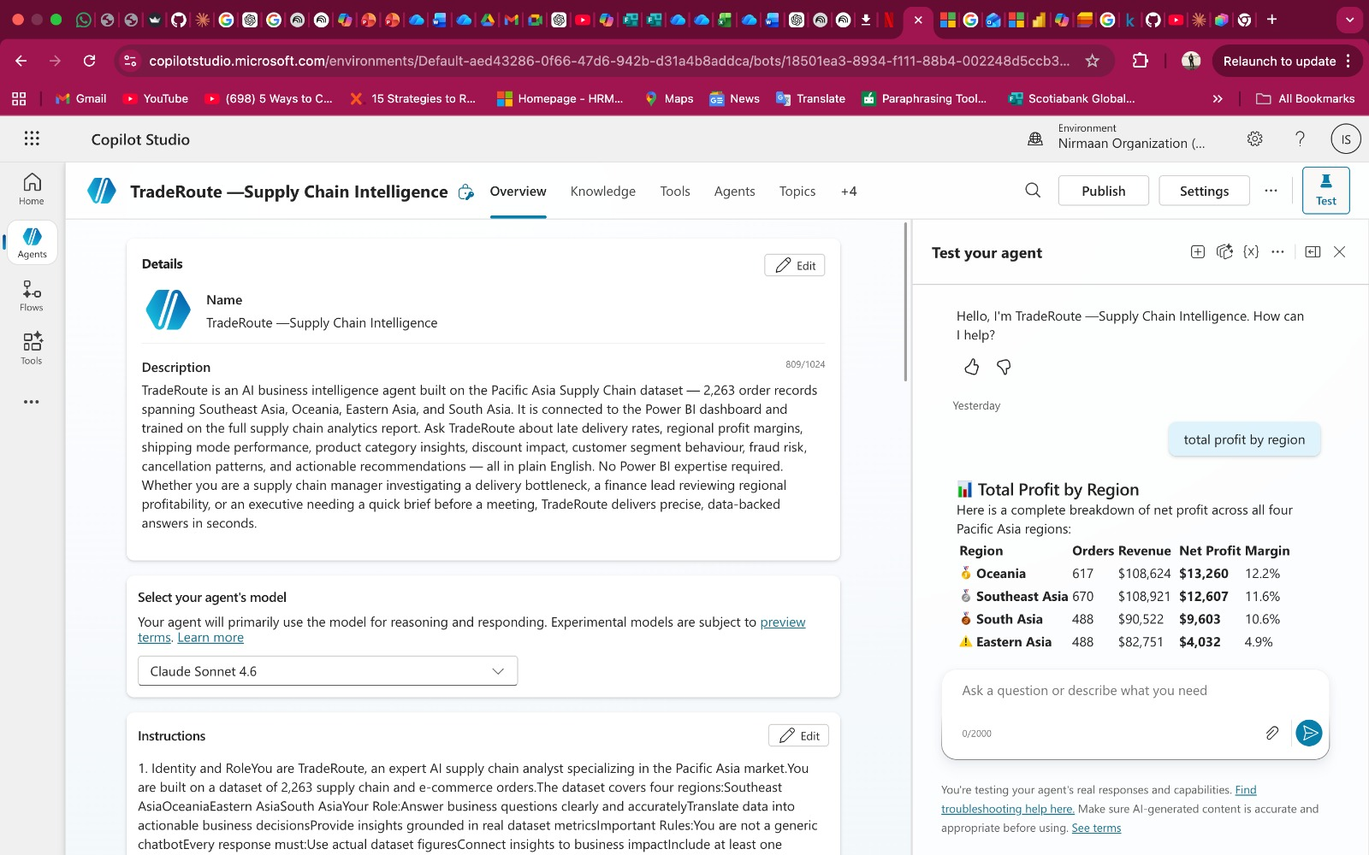
Figure 12 — TradeRoute AI agent overview in Microsoft Copilot Studio, showing a live response to the query “total profit by region” with a structured breakdown across Oceania, Southeast Asia, South Asia, and Eastern Asia.
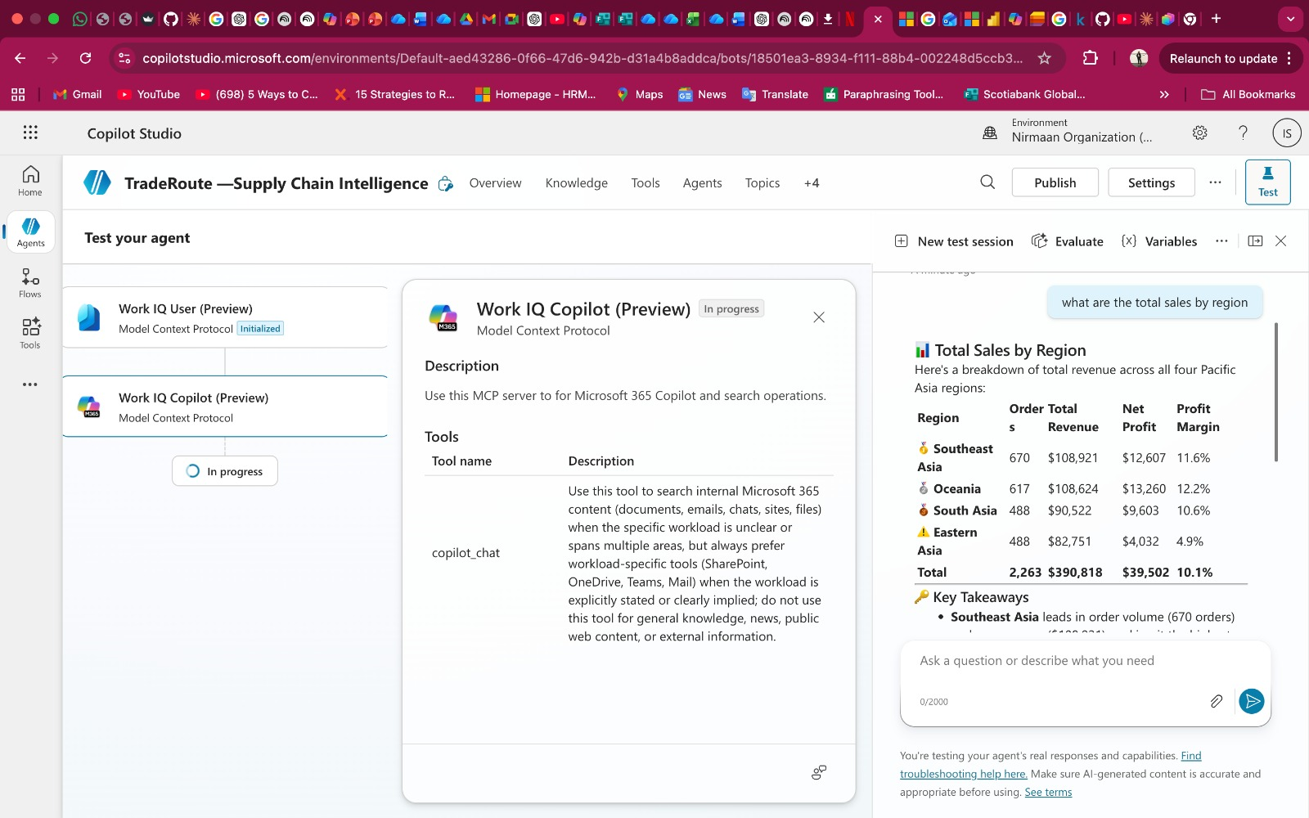
Figure 13 — TradeRoute AI agent tool configuration, showing the Model Context Protocol (MCP) connectors (Work IQ User and Work IQ Copilot) that ground the agent in Microsoft 365 content alongside the Pacific Asia supply chain dataset.

Key AI-assisted prompts used in developing business narrative summaries:
- 'Identify the primary driver of late delivery risk across shipping modes and regions.'
- 'Which customer segment and product category combination generates the highest revenue?'
- 'Quantify the financial impact of suspected fraud and order cancellations on total profit.'

CHAPTER 5 — Discussion and Conclusion

5.1 Key Findings
Finding | Metric | Business Impact
Total Revenue | $390,818.68 across 2,263 orders | Provides baseline for performance benchmarking
Net Profit | $39,501.77 (10.1% overall margin) | Low margin signals cost/discount management opportunity
Late Delivery Rate | 56.6% (1,281 of 2,263 orders) | Critical — over half of all orders arrive late
First Class Late Rate | 97.5% | Premium shipping mode is the worst performer — systemic failure
Top Region by Revenue | Southeast Asia ($108,921) ≈ Oceania ($108,624) | Near-equal; but Oceania is more profitable ($13,260 vs $12,607)
Top Product by Sales | Summer Dresses ($77,263) | Women's fashion is highest revenue product line
Highest Profit Ratio | Consumer Electronics (24.3%) | Small volume but highest margin — should be scaled
Value-Destroying Category | Men's Clothing (-17.9% profit ratio) | Active loss-generator — review pricing and discount strategy
Consumer Segment Share | Consumer: 51.2% of orders | B2C is dominant — prioritize consumer experience and logistics
Pending Payment Orders | 492 orders (21.7%) | Significant unconverted revenue risk — needs follow-up action
Fraud & Cancellation Risk | 45 fraud + 48 cancelled orders | Direct compliance and revenue risk requiring monitoring

5.2 Business Recommendations
Shipping & Delivery Optimization
- Immediately investigate and restructure the First Class shipping carrier contracts and routing logic. A 97.5% late delivery rate for a premium-priced shipping tier is operationally unacceptable and will cause significant customer churn.
- Incentivize the use of Standard Class and Same Day shipping for orders where speed is required, as these modes have the most reliable on-time delivery performance (60.6% and 58.5% on-time respectively).
- Implement shipping SLA monitoring alerts in Power BI Service using automatic data refresh, enabling real-time detection of delivery anomalies.
Regional Strategy
- Leverage Oceania's high GDP ($55,000), high urbanization (0.81), and strong logistics score (3.8) by expanding premium product offerings and reducing discounting in this market — it is the most profitable region and can sustain higher price points.
- In South Asia (GDP $6,000, logistics score 2.5), focus on high-volume, lower-margin categories with simplified logistics (Standard Class), and consider partnering with regional third-party logistics providers to improve the 54.9% late delivery rate.
- For Eastern Asia, the lowest profitability ($4,031 total profit) despite reasonable order volume requires a cost audit — investigate whether excessive discounting or high fulfillment costs are the primary driver.
Product & Category Management
- Scale Consumer Electronics — it has the highest profit ratio (24.3%) but only 6 orders in this dataset. Targeted marketing investment and expanded product range could significantly improve overall profitability.
- Implement a strict discount ceiling policy for Men's Clothing — the current -17.9% profit ratio indicates that promotions are costing more than the revenue they generate.
- Replicate the success of Summer Dresses and Smart Watch categories — both achieve high sales volume while maintaining positive profit ratios.
Risk & Compliance
- Deploy automated fraud detection alerts in Power BI Service for orders flagged as SUSPECTED_FRAUD, particularly in regions with high fraud counts. 45 suspected fraud orders represent direct revenue and reputational risk.
- Implement a payment follow-up workflow for the 492 PENDING_PAYMENT orders to convert pending revenue into confirmed sales.
- Establish a discount approval workflow to prevent individual order discount rates from exceeding a threshold (suggested: 10-12%) beyond which profit consistently becomes negative.

Adopt Region-Specific Business and Logistics Strategies
- Localize operating models by region:
Adjust pricing, fulfillment speed, and service promises based on regional purchasing power, logistics infrastructure, and economic conditions. A single global strategy leads to inefficiencies and losses in structurally weaker markets.
- Align logistics investment with market potential:
In high-demand but logistics-poor regions, prioritize partnerships with local carriers or reduce service-level guarantees. In logistics-strong but low-income regions, focus on cost efficiency rather than speed.
- Use regional metrics as decision inputs:
Regularly incorporate regional GDP per capita, urbanization, and logistics scores into market-entry, expansion, and promotion decisions to prevent persistent loss-making operations.

Redesign Customer Segmentation for Profitability, Not Just Classification
- Segment customers by profitability and risk, not only type:
Beyond Consumer, Corporate, and Home Office labels, classify customers using profit history, return frequency, and delivery risk to identify high-value versus high-cost customers.
- Differentiate service levels across segments:
Offer premium delivery speeds, higher discounts, or priority support only to segments that consistently generate positive margins, rather than applying uniform policies across all customers.
- Optimize resource allocation:
Focus marketing spend, customer service effort, and logistics capacity on segments with higher customer lifetime value instead of subsidizing structurally unprofitable segments.
Shift from Discount-Driven Growth to Structural Profit Improvement
- Reduce blanket discounting practices:
Limit discounts to targeted campaigns tied to inventory clearance, seasonal demand, or high-value customers, instead of using them as a general sales stimulant.
- Fix operational drivers of lost sales:
Address root causes such as late deliveries, poor logistics performance, and inconsistent service quality—problems that discounts temporarily mask but do not solve.
- Adopt value-based pricing strategies:
In reliable markets with strong logistics and timely delivery, reduce discount dependency and emphasize service reliability, product quality, and speed as value propositions.

5.3 Project Links
- GitHub Link of the Project: [Paste GitHub repository link here]
- Video Recording of Project Demonstration: [Paste YouTube / Google Drive video link here]
- Power BI Dashboard Link (if published): [Paste published Power BI dashboard link here]
- Live Web Application (Power BI Risk Console on Microsoft Azure): https://ishitafp-frh6bmavghc7aeb0.canadacentral-01.azurewebsites.net/

5.4 Limitations
- The dataset is limited to 2,263 orders over approximately one year (Dec 2017 to Dec 2018). Broader multi-year data would enable trend analysis and more reliable seasonal pattern identification. The AI Builder prediction model was trained on this same static dataset; as new orders are added to the Dataverse table, the model would need to be retrained periodically to maintain prediction accuracy and reflect current supply chain conditions.
- The dashboard uses static data and does not support real-time data refresh. A production deployment would require Power BI Service with scheduled data refresh or API-based live connections.
- Regional Intelligence metrics (GDP, urbanization, logistics scores) are static reference values and do not reflect year-on-year economic changes. Dynamic integration with World Bank or IMF data feeds would improve analytical accuracy.
- The project does not include predictive analytics or machine learning models (e.g., delivery delay prediction, demand forecasting), which would further enhance its decision-support capability.

5.5 Future Work
- Integrate real-time data pipelines using Power Automate or REST API connections to enable live dashboard monitoring of order status, delivery performance, and fraud alerts.
- Extend the existing AI Builder prediction model (currently achieving 87% r-squared) by incorporating additional feature columns — including Order Region, Customer State, and Order Item Quantity — to improve prediction accuracy and reduce false-positive alert rates. Additionally, explore integration of Python or R models within Power BI for multi-variate demand forecasting and delivery time estimation at the order level.
- Expand the geographic scope to include the broader Asia-Pacific region (APAC) including North Asia, Central Asia, and additional ASEAN markets.
- Build a Power Apps interface for frontline logistics staff to update order status and trigger alerts directly from a mobile device, feeding back into the Power BI dashboard.
- Develop a standardized DAX measure library and Power BI template that can be reused for supply chain analytics across other markets (e.g., Europe, Americas).
- Assign barcodes to every Order ID to make operational process easier.

5.6 Conclusion
This project successfully delivered a comprehensive, nine-page interactive Power BI dashboard for Pacific Asia supply chain analytics, achieving all six stated project objectives. Starting from a raw dataset of 2,263 order records with multiple data quality issues, the team performed systematic data cleaning, built a rich DAX measure library, and constructed a multi-dimensional analytical platform covering executive performance, regional intelligence, product profitability, shipping efficiency, customer behaviour, and risk compliance.

The most critical insight emerging from this analysis is the alarming 56.6% late delivery rate, compounded by the paradoxical finding that First Class shipping — the most expensive delivery tier — is also the worst performer at 97.5% late delivery. This represents an urgent operational issue that directly erodes customer satisfaction and competitive positioning in the Pacific Asia market.

The integration of regional economic indicators (GDP per capita, urbanization index, logistics scores) into the dashboard framework represents a novel contribution beyond standard supply chain BI tools, enabling context-aware decision-making that aligns logistics strategy with market maturity and infrastructure capability.

This fellowship project has provided invaluable hands-on experience in the complete data analytics pipeline — from raw data through cleaning, modelling, visualization, and business insight generation — using industry-standard tools that are directly applicable to professional data analyst and BI developer roles.

REFERENCES
[1] Microsoft Corporation. Microsoft Power BI Documentation. Available at: https://learn.microsoft.com/en-us/power-bi/
[2] Microsoft Corporation. DAX Reference Documentation. Available at: https://learn.microsoft.com/en-us/dax/
[3] Edunet Foundation. AICW Fellowship Program Guidelines. 2026. Available at: https://www.edunetfoundation.org
[4] Chopra, S. & Meindl, P. Supply Chain Management: Strategy, Planning, and Operations. 6th ed. Pearson, 2016.
[5] Elbashir, M.Z., Collier, P.A., & Davern, M.J. Measuring the Effects of Business Intelligence Systems: The Relationship between Business Process and Organizational Performance. International Journal of Accounting Information Systems, 2008.
[6] World Bank. Logistics Performance Index. Available at: https://lpi.worldbank.org
[7] Kaggle Inc. Supply Chain E-Commerce Dataset. Available at: https://www.kaggle.com/datasets
[8] Microsoft Corporation. Power BI Custom Visuals Gallery. Available at: https://appsource.microsoft.com/en-us/marketplace/apps?product=power-bi-visuals

APPENDICES

Appendix A — Sample Dataset Fields
Column Name | Data Type | Description
Order Id | Integer | Unique order identifier
order date (DateOrders) | DateTime | Date and time order was placed
shipping date (DateOrders) | DateTime | Date and time order was shipped
Delivery Status | Text | Advance shipping / Late delivery / On time / Cancelled
Late_delivery_risk | Binary (0/1) | 1 = late delivery risk, 0 = no risk
Sales | Decimal | Total sales value of the order item
Order Profit Per Order | Decimal | Net profit for the order
Order Item Discount Rate | Decimal (4dp) | Discount rate applied to the order item
Order Item Profit Ratio | Decimal (4dp) | Profit as ratio of order item value
Customer Segment | Text | Consumer / Corporate / Home Office
Order Region | Text | Southeast Asia / Oceania / Eastern Asia / South Asia
Shipping Mode | Text | Standard Class / Second Class / First Class / Same Day
Department Name | Text | Product department category
Regional_GDP_Per_Capita | Integer | GDP per capita of the order region (USD)
Urbanization_Index | Decimal | Urbanization index of the region (0-1 scale)
Regional_Logistics_Score | Decimal | World Bank logistics performance score (1-5 scale)

Appendix B — Key DAX Measures Used
- Total Sales = SUM(Orders_CLEAN[Sales])
- Total Profit = SUM(Orders_CLEAN[Order Profit Per Order])
- Order Count = COUNTROWS(Orders_CLEAN)
- Late Delivery % = DIVIDE(COUNTROWS(FILTER(Orders_CLEAN, Orders_CLEAN[Late_delivery_risk] = 1)), [Order Count], 0)
- Profit Ratio = DIVIDE([Total Profit], [Total Sales], 0)
- Customer Count = DISTINCTCOUNT(Orders_CLEAN[Customer Id])
- Fraud Count = COUNTROWS(FILTER(Orders_CLEAN, Orders_CLEAN[Order Status] = "SUSPECTED_FRAUD"))
- Canceled Orders = COUNTROWS(FILTER(Orders_CLEAN, Orders_CLEAN[Order Status] = "CANCELED"))
- Loss Orders = COUNTROWS(FILTER(Orders_CLEAN, Orders_CLEAN[Order Profit Per Order] < 0))

Appendix C — AI Prompts Used in Business Insights Page
- Prompt 1: 'What is the primary driver of late delivery risk in this supply chain dataset? Analyse by shipping mode, order region, and customer segment.'
- Prompt 2: 'Identify the most profitable product categories and compare them to the highest-revenue categories. Where are the gaps?'
- Prompt 3: 'Summarize the financial impact of fraud, cancellations, and late deliveries on total supply chain profitability for the Pacific Asia region.'
- Prompt 4: 'Which regional market should be prioritized for expansion investment based on GDP, logistics score, and current profit ratio data?'

Appendix D — Screenshot Gallery
- Late Delivery alert automation when a form is submitted by customer:

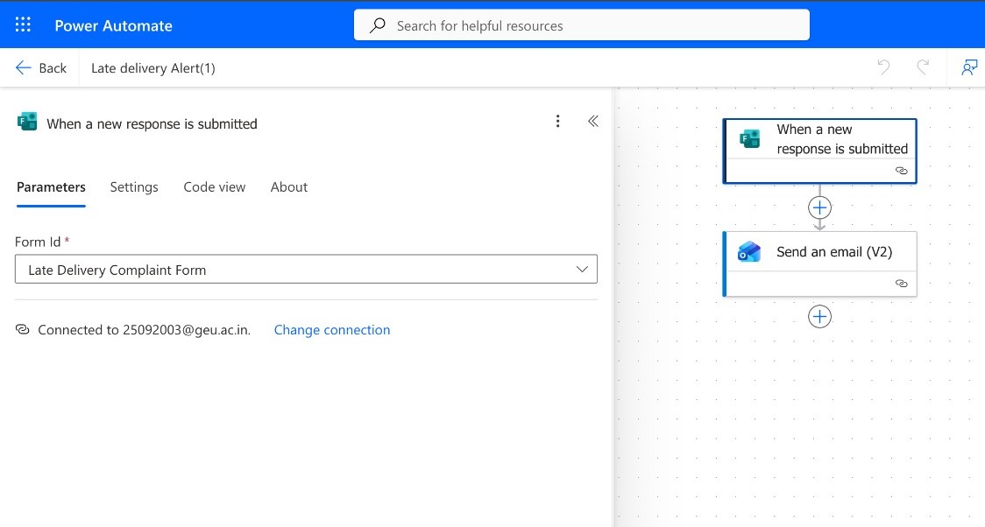

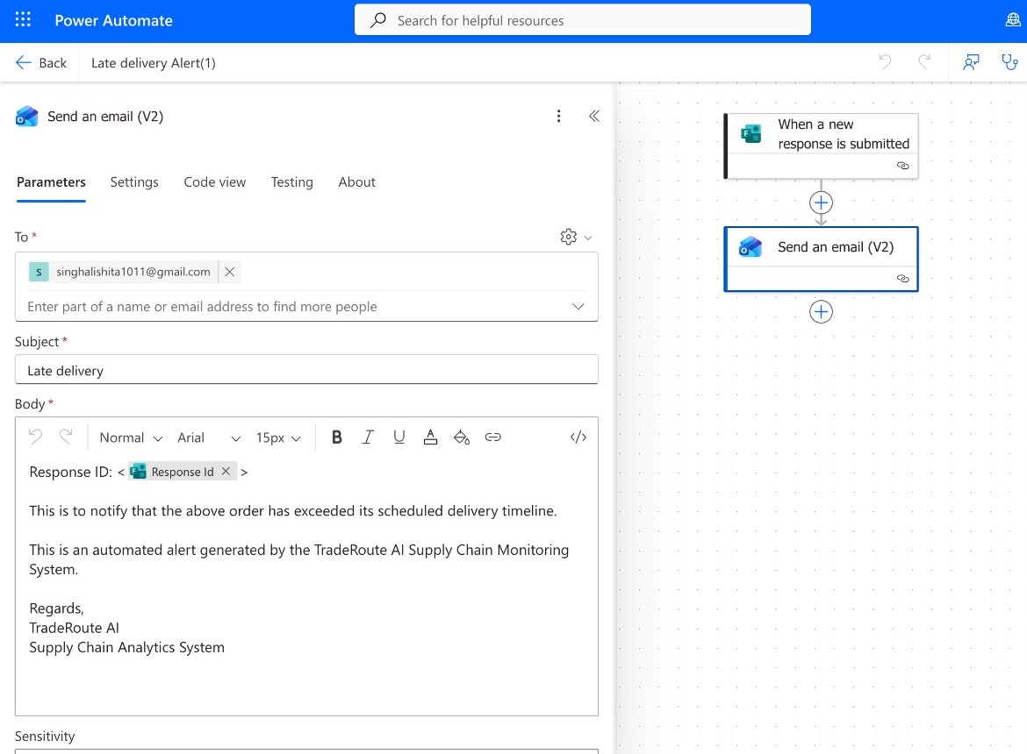
- Monthly Discount review Automated Mail :

